Submission for Highlight Track

Abstract Template for Poster Submission in InCoB 2018

Presenting Author Name, Other Author1, Other Author2, Corresponding Author Name*

School of Computational & Integrative Sciences, Jawaharlal Nehru University,
New Delhi, India

Email: PAN: wtp@testserver.com; CAN: cdun@testserver2.com

This section should contain maximum of 150 words and summarize the scientific contents of the work to be presented [1]. References should inclide only the papers of the presenting/ corresponding authors of this submission. Figures must be cited inside the text and presented in a tabular format. (Figure 1). Resolution of Figures should be high as described in poster submission guidelines. The text of the manuscript should be written in a concise and crisp manner [3]. Font sizes and referencing style must be respected [2]. Figures must be cited inside the text and presented in a tabular format. (Figure 2).

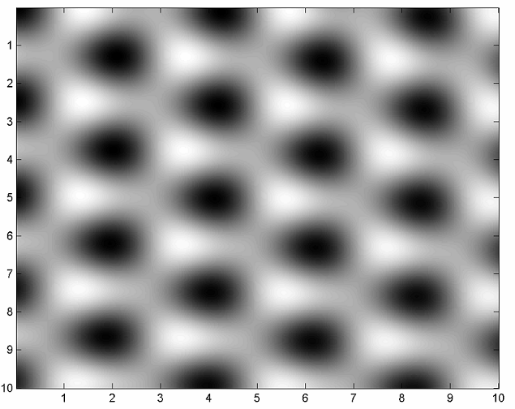 | 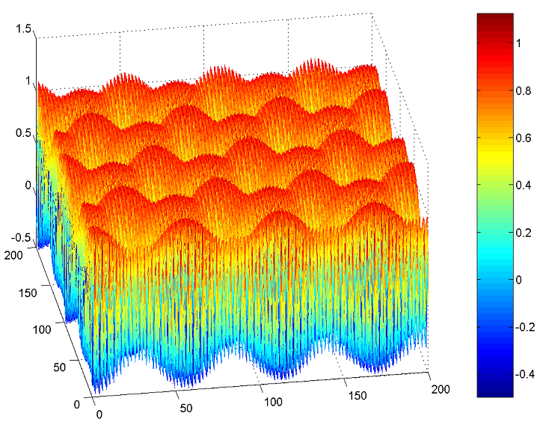
Figure 1: Caption | Figure 2: Caption | Figure 3: Caption

References:
[1] C.R. Clemmer, T.P. Beebe Jr., Science 251 (1991) 640-642
[2] J. Xhie, K. Sattler, M. Ge, N. Venkateswaran, Phys. Rev. B 47 (1993) 15835-15840
[3] R. Hentschke, B. Schurmann, J. Rabe, J. Chem. Phys. 96 (1992) 6213-6217

Justification for inclusion as Highlight track presentation:
This section should explain why this work is important for InCoB participants and describe the level of interest the highlighted work has generated so far (e.g. the number of citations, downloads, page views or Tweets mentioning the paper on which this work is based). The cited papers must be included in the above section and not here and should be the own publications of authors. This section should not exceed 100 words.

