Abstract Template for Poster Submission in InCoB 2018

Presenting Author Name, Other Author1, Other Author2, Corresponding Author Name*

School of Computational & Integrative Sciences, Jawaharlal Nehru University,
New Delhi, India

Email: PAN: wtp@testserver.com; CAN: cdun@testserver2.com

The text of the manuscript should be written in a concise and crisp manner [1]. Font sizes and referencing style must be respected [2]. Figures must be cited inside the text and presented in a tabular format. (Figure 1). Resolution of Figures should be high as described in poster submission guidelines. The text of the manuscript should be written in a concise and crisp manner [3]. Font sizes and referencing style must be respected [2]. Figures must be cited inside the text and presented in a tabular format. (Figure 2). Resolution of Figures should be high as described in poster submission guidelines. The text of the manuscript should be written in a concise and crisp manner [4]. Font sizes and referencing style must be respected [1,2]. Figures must be cited inside the text and presented in a tabular format. (Figure 3). Resolution of Figures should be high as described in poster submission guidelines.

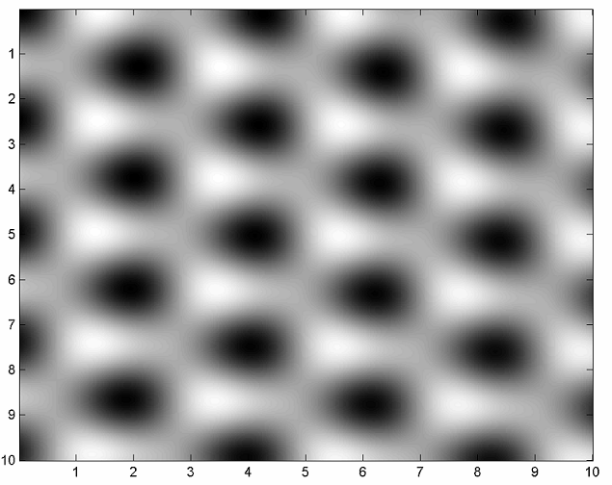 | 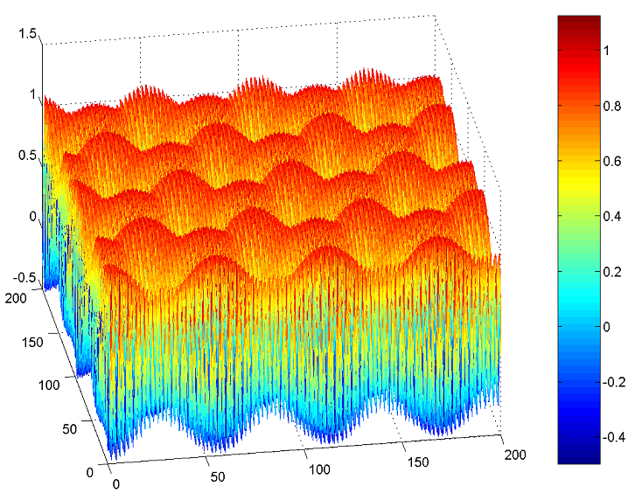
Figure 1: Caption | Figure 2: Caption | Figure 3: Caption

References
[1] C.R. Clemmer, T.P. Beebe Jr., Science 251 (1991) 640
[2] J. Xhie, K. Sattler, M. Ge, N. Venkateswaran, Phys. Rev. B 47 (1993) 15835
[3] R. Hentschke, B. Schurmann, J. Rabe, J. Chem. Phys. 96 (1992) 6213
[4] W.T. Pong, C. Durkan, J. Bendall, “Observation of Large-Scale Features on Graphite under Scanning Tunnelling Microscope” 12th International Colloquium on Scanning Probe Microscopy in Shizuoka, Japan 2004.

