Highlight Title

Presenting Author Name¹, Other Author¹, Other Author¹, Corresponding Author Name^{1,*}

¹School of Data Sciences, Affiliation organisation, Country

Presenting Author: janedoe@abc.org;
*Corresponding Author: johndoe@ abc.org

The text “Extended Abstract Template for Highlight” can be removed from the submission. This section should contain maximum of 150 words and summarize the scientific contents of the work to be presented [1]. References should include only the papers of the presenting/ corresponding authors of this submission. Figures must be cited inside the text and presented in a tabular format (Figure 1). Resolution of Figures should be high as described in poster submission guidelines. The text of the manuscript should be written in a concise and crisp manner [3]. Font sizes and referencing style must be respected [2]. Figures must be cited inside the text and presented in a tabular format. (Figure 2).

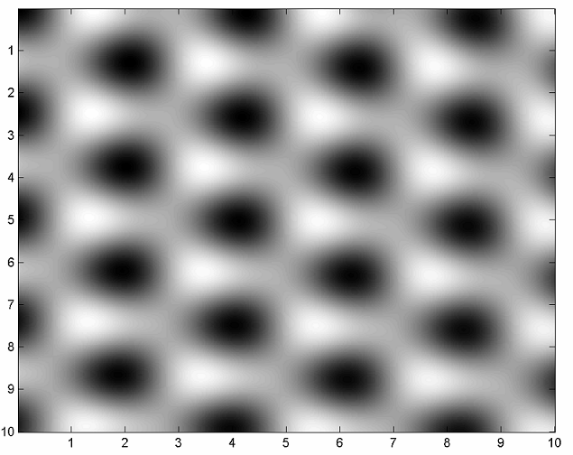 | 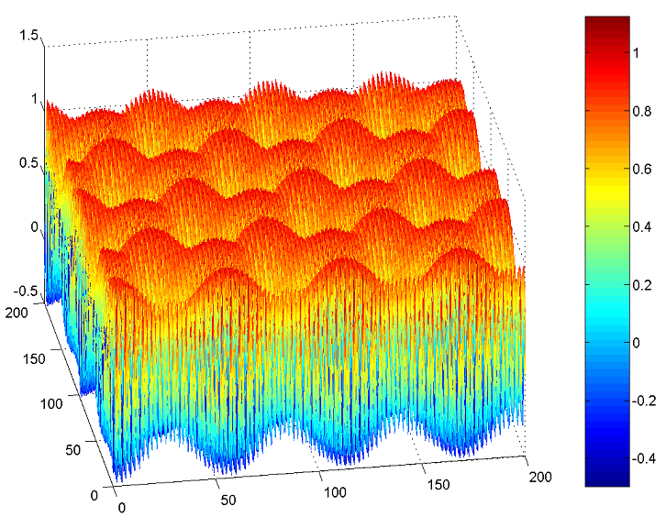
Figure 1: Caption | Figure 2: Caption | Figure 3: Caption

References:
[1] C.R. Clemmer, T.P. Beebe Jr., Science 251 (1991) 640-642
[2] J. Xhie, K. Sattler, M. Ge, N. Venkateswaran, Phys. Rev. B 47 (1993) 15835-15840
[3] R. Hentschke, B. Schurmann, J. Rabe, J. Chem. Phys. 96 (1992) 6213-6217

Use italics for journal name, bold font for volume number and brackets for year of publication. Only list the first two authors; if more add “and et al.”

Justification for inclusion as Highlight track presentation:
This section should explain why this work is important for the conference participants and describe the level of interest the highlighted work has generated so far (e.g. the number of citations, downloads, page views or Tweets mentioning the paper on which this work is based). The cited papers must be included in the above section and not here and should be the own publications of authors. This section should not exceed 100 words.

